
Bonytail (Gila elegans): Proposed Integrated Population Model
LCR MSCP Native Fish Data Synthesis, Phase 3 · Sub-Task 2: Bonytail Demographic Analysis
Sound Science LLC · 16 September 2026
DRAFT FOR ADVISORY PANEL REVIEW

1. Purpose and scope
This document describes the integrated population model (IPM) proposed for bonytail (BONY) under Sub-Task 2 of Phase 3. It is intended to orient advisors to the model's biological basis, its structure as a Bayesian graphical model, the data streams it consumes, and the parameters it estimates.
Bonytail is among the most endangered fishes in North America and is now maintained in the Lower Colorado River almost entirely through hatchery production: fish are reared to adult size and stocked, rather than recruiting naturally at scale. This fact shapes the entire modeling approach. The BONY analysis therefore comprises two complementary components that reflect the contrasting demographic patterns observed in off-channel habitat (OCH) ponds versus open-water releases:
- Off-channel (OCH) IPM: an integrated model joining individual encounter histories and counts of wild-hatched recruits, fitted to data collected following BONY releases into predator-free conservation ponds: Imperial Ponds Conservation Area (IPCA) Ponds 2, 5 and 6 from 2016 onward, and Cibola High Levee Pond (CHLP) before 2016. Ponds 1 and 3 and Yuma Cove are excluded because survey effort there is too sparse. CHLP's record after 2016 cannot support survival estimation: few of the fish entering the record there from 2016 onward were ever detected again, fish transferred out of the pond break its closure, and tagging of the juveniles recruited there was not consistent after the stocked adults had died off. These ponds show demographic continuity across years and documented natural reproduction.
- Open-water Cormack–Jolly–Seber (CJS) model: a survival-only model fitted to post-release encounter data across all mainstem reaches. A full IPM is not warranted in open water because apparent post-release six-month survival is near zero. Stocked fish largely disappear within weeks, assumed due chiefly to predation by birds and fishes, with an estimated 85% perishing within the first month (Kelley et al. 2022); they do not persist across years, and there is no demographic continuity for a process model to track.
The two components together quantify the OCH-versus-open-water survival contrast that underpins the MSCP question of the relative merits of releases into disconnected-versus-connected backwaters, and they supply the vital-rate estimates and covariate effects used later for alternate-stocking scenario analysis and refuge-site feasibility ranking. Sub-Task 2 addresses research questions Q2, Q3, Q6, and Q7 for BONY, and Q15 (refugia environmental thresholds at CHLP/IPCA).

2. The bonytail life cycle
The model's biological backbone is the LCR MSCP Bonytail Conceptual Ecological Model (Braun 2019, Figure 1), collapsed to the annual time step used by the IPM. Only the later stages are observable: a stocked fish enters the record at release, and a pond-hatched fish when it is first caught, at which point its length places it in the year it hatched. Survival before a fish is large enough to be netted is therefore folded into the reproduction term rather than projected separately. The model follows two groups: stocked fish, carried forward by survival from release, with the first year after entry treated as a distinct survival step; and pond-hatched cohorts, carried forward from the year they hatched with their own survival at ages 0 and 1 and adult survival thereafter, and counted as spawners once they reach spawning age. Spawning is treated as a within-year process folded into the reproduction term, so that spawning survival is not double-counted against adult survival.
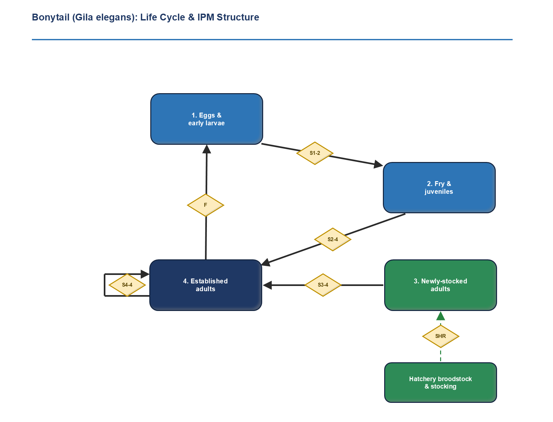
Figure 1. Bonytail life cycle and IPM structure, adapted from the BONY Conceptual Ecological Model (Braun 2019). Diamonds are life-history rates; the annual time step folds spawning into the reproduction term F.
Two features distinguish the bonytail cycle from a conventional wild-fish life history:
- Stocking is the dominant input. Hatchery broodstock produce fish that are stocked as adults (not fry) into the “newly-stocked adult” stage. Stocking enters the IPM as a known quantity (dashed input), not an estimated rate.
- Natural recruitment closes the cycle only in isolated ponds. The early-stage survivals (S1–2, S2–4) and the reproduction term F are realized only in predator-free OCH ponds; in open water the loop effectively does not close. Survival before fish reach a size the nets can catch is not estimated separately and sits in F. Survival over the next two years, at ages 0 and 1, is estimated: wild-hatched fish tagged young inform it through their later encounters, and the year each recruit was first netted informs it through the timing of first capture.
- Origin is carried instead of stage. Each fish is classed at entry as stocked, if a stocking record accounts for it, or wild-hatched, and the class is never revised. Origin enters survival with a pond-specific deviation, so the model does not assume the origin effect is the same in every pond.
The CEM's stage-transition labels map onto the IPM's demographic rates as follows; the life-cycle figure retains the CEM “S” notation, while the IPM and its graphical model use φ for survival.
CEM rate (Fig. 1) | IPM parameter | Meaning / where estimable
SHR | (known input) | Hatchery survival / output: stocked adults enter as known additions.
S3–4 | φ³ | First-year survival after entry (newly-stocked → established), estimated in the ponds as a step on established-adult survival; ~0 in open water (CJS only). An origin-by-first-year term lets the step differ for wild-hatched fish.
S4–4 | φ⁴ | Established-adult annual survival, by pond, origin and pond-year; estimated by the OCH IPM (IPCA Ponds 2, 5 and 6; CHLP before 2016).
S1–2, S2–4 before netting size | (folded into F) | Survival of eggs, larvae and fry until they are large enough to be netted; realized only in isolated, predator-free ponds. Not estimable separately from reproduction.
S2–4 at ages 0 and 1 | φj | Juvenile survival from age 0 to 1 and from 1 to 2, estimated as a step on wild-hatched adult survival from fish tagged young and the year recruits were first netted; OCH ponds only.
F | F | Recruitment, estimated as recruits per spawner corrected for detection, by pond and hatch year. It includes survival from hatching to netting size; closes only where recruitment occurs.

3. Model structure as a Bayesian graphical model
Figure 2 renders the single-population BONY IPM as a directed acyclic graph (DAG). It is not a flowchart of the life cycle; it shows how latent demographic quantities generate the observed data, and which parameters are shared across the model's constituent sub-models. The integration, the defining feature of an IPM, appears as the overlaps between the dashed sub-model boxes: a parameter sitting in an overlap is estimated jointly from every data stream that depends on it. This joint-likelihood integration is the defining property of an IPM (Besbeas et al. 2002; Schaub and Abadi 2011), and the graphical-model conventions used here follow Schaub and Kéry (2022).
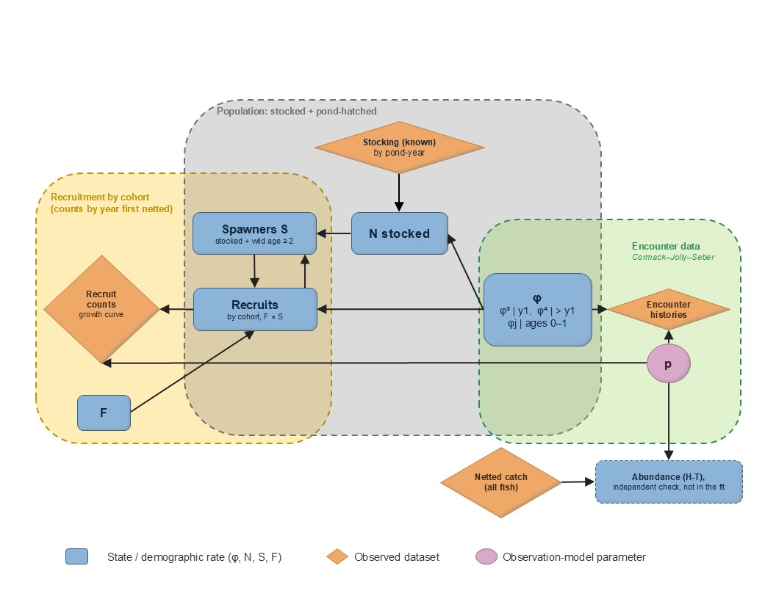
Figure 2. The bonytail IPM as a joint graphical model. Blue = latent states and demographic rates; orange diamonds = observed datasets; pink circles = observation-model parameters. Dashed boxes are the sub-models and overlaps mark shared nodes. Each cohort of recruits becomes part of the spawners of later years. Recruit counts are split by the year each recruit was first netted; survival φ includes juvenile steps at ages 0 and 1, and detection p carries separate catchability for fish at ages 0 and 1 on each gear. The abundance estimate outside the boxes is computed from the netting and antenna records, is not part of the likelihood, and serves as an independent check on the population the model projects.
Three sub-models are joined:
- Recruitment sub-model (gold). Counts of wild-hatched recruits are tabulated by the year each hatched, back-calculated from length at first capture, and by the year each was first netted. Each count is modelled as Poisson. The mean is the number of fish the cohort started with, F times the spawners S in its hatch year, multiplied by the probability that a fish of that cohort is alive and not yet netted at the start of that year and the probability that it is netted during it; a pond-year random effect on log F accounts for the overdispersion. Summed over years, the mean is the cohort's size times the probability that its fish are ever netted. F is therefore recruits per spawner, corrected for detection (Section 5).
- Population sub-model (grey). Each pond is closed and begins from a documented stocking, so every fish in it is either a stocked fish or a fish hatched there. Stocked fish, all tagged at release, are carried forward by survival from the stocking records. Each pond-hatched cohort is carried forward from the year it hatched, from the size the recruitment sub-model gives it, by juvenile survival at ages 0 and 1 and adult survival thereafter. The spawners S in a year are the stocked survivors plus pond-hatched fish old enough to spawn, and the population aged one and over is the quantity population growth is measured on.
- Encounter sub-model (green; CJS). Individual PIT-tag encounter histories from the ponds are generated by survival, φ³ in the first year after entry and φ⁴ thereafter, together with the detection probability p, which has separate netting and antenna channels.
Survival sits in the overlap of the population and CJS boxes, because it drives both the individual encounter histories and the survival of stocked fish and pond-hatched cohorts; juvenile survival is informed by wild-hatched fish tagged at ages 0 and 1 and carries the cohorts through those ages. The spawners and the recruits sit in the overlap of the population and recruitment boxes, because each cohort's size depends on the spawners that produced it, and each cohort in turn joins the spawners of later years. Detection p reaches into the recruitment box, because the netting hazard estimated from tagged fish also sets the chance that a recruit is caught in each year; for fish at ages 0 and 1 that hazard carries its own catchability on each gear, identified by the years in which recruits were first netted. That shared dependence is what lets the model reconcile the data streams into a single, demographically consistent set of estimates rather than disconnected analyses.
The model joins two likelihoods (the individual encounter histories and the recruit counts) through a shared survival process, a shared detection process and the population they project. It carries the whole population, stocked and pond-hatched, tagged or not, but it does not include a likelihood for total counts. The total abundance estimated from the netting and antenna records is kept outside the model deliberately, so that it can test the population the model rebuilds (below).
Detection is identified internally, because every fish carries an individual PIT tag: a tagged fish contacted before and after a year but missed within it is known to have been present, and each such gap estimates the detection probability. The two observation methods enter as separate detection channels on the same latent state: continuous PIT scanning, with high detection of tagged fish, and episodic netting, with lower detection but the only method that also captures untagged fish. Stocked fish enter as known additions and pond-hatched cohorts through the recruit counts, so no separate count observation model or observation error σ is needed.
Total abundance, tagged and untagged, is estimated outside the model, only in pond-years netted heavily enough to support it, and compared with the population the model projects. Because these totals never enter the likelihood, agreement between the two is an independent check on the recruitment and population components. The estimator is the two-group Horvitz-Thompson form of Dzul et al. (2021), which splits the catch by marking status because the two groups are seen by different means. Each tagged fish encountered is weighted by the inverse of its probability of being netted or read on an antenna; each untagged fish caught is weighted by the inverse of its netting probability alone, at its own measured length, because an untagged fish cannot be read by an antenna. Both probabilities come from the fitted model and the estimate is computed at every posterior draw, so uncertainty in detection is carried into it. Where a pond is netted in two sessions within one season, a within-season mark-recapture estimate of the same fish (Chapman 1951) gives a further check that uses no model parameter at all.

4. Data streams and parameters
All datasets are individual-level records linked by PIT-tag ID, reconstructed from release through every subsequent contact (summary tables and aggregated counts are not sufficient). The principal streams and what each informs:
Data stream | Source | Primarily informs
Stocking records | MSCP / Native Fish Database | Known additions to the newly-stocked stage; anchors abundance.
Remote PIT-scan + net encounter histories (OCH) | IPCA Ponds 2, 5 and 6; CHLP before 2016 | Survival φ³ and φ⁴ by pond and origin; detection p by channel.
Open-water post-release encounters | PIT antennas + physical recapture, all reaches | Post-stocking survival curve φ³ by reach, size at release, release method.
Wild-hatched recruits, by hatch year and year first netted | Netting records; hatch year back-calculated from length at first capture | Recruitment F per spawner, corrected for detection; catchability at ages 0 and 1; juvenile survival.
Lengths of recaptured wild-hatched fish | IPCA netting records | The growth curve that assigns recruits to hatch years.
Netted catch, tagged and untagged | IPCA netting records; antenna detections of tagged fish | Total abundance, by two-group Horvitz-Thompson estimation outside the model; an independent check on the modelled population.
Within-season recaptures | IPCA netting in two sessions of one season | Spawner-sized abundance by mark-recapture, outside the model; an independent check.
Survey effort | Net-nights by gear (hoop, trammel); antenna scan time | Detection p, as an effort-driven hazard, and through it the chance a recruit is ever netted.
Environmental monitoring | IPCA dissolved oxygen, temperature, water level | Environmental covariates (Q15). The 2020/2022 die-offs were operational (pump failure), not environmental (Marsh et al. 2024).

Estimated quantities are survival by pond, origin and pond-year, with a first-year step (φ³) on established-adult survival (φ⁴) and juvenile survival steps for pond-hatched fish at ages 0 and 1; the detection probability p by channel, gear, fish length and pond-year, with separate netting catchability for fish at ages 0 and 1 on each gear; recruitment F per spawner by pond and hatch year; and the pond population, stocked and pond-hatched, with its spawners S and its growth rate. Total abundance is estimated outside the model as a check (Section 3), and no count observation error σ is estimated. Which of these is identifiable depends on the setting: in the predator-free OCH ponds the full set is estimable, whereas in open water only φ³ (and detection) can be recovered, because there is no persistent population for a process model to follow.
Detection is not treated as constant. p varies by observation method (remote PIT scanning in open water and the ponds, plus netting in the ponds) and with survey effort, which differs by site and year; effort enters p as a hazard, so that an unevenly sampled year is not misread as a change in survival or abundance. Netting detection is further split by gear and depends on fish length, because hoop nets and trammel nets differ in catchability and small fish are harder to net. Pond-hatched fish at ages 0 and 1 carry their own catchability on each gear, because the hazard estimated from tagged fish, most of them past that size, cannot be assumed to hold for fish that small; splitting the recruit counts by the year each fish was first netted identifies it. A pond-year detection effect absorbs surveys that under-delivered against their recorded effort. Residual among-individual variation in detectability, which biases abundance high and survival low if ignored, is proposed as a sensitivity analysis: a two-class finite mixture on the netting hazard, in which each fish belongs to an unobserved high- or low-catchability class.

5. Estimating reproduction (F) from recruit counts
Reproduction is the parameter that closes the life cycle in the isolated off-channel ponds. It is estimated from counts of wild-hatched recruits.
A wild-hatched fish that is caught is aged by back-calculation through a von Bertalanffy growth curve and assigned to the year it hatched. The curve is fitted to the length increments of wild-hatched fish recaptured in these ponds (Fabens 1965), which requires no known ages. Recruits are counted by pond, hatch year, and the year each was first netted, and each count is modelled as Poisson with mean F × S × P(j), where S is the spawners in the hatch year and P(j) is the probability that a fish of that cohort is first netted in year j: alive and not yet netted at the start of the year, then netted during it.
The resulting F is recruits per spawner, corrected for the chance of being caught, and it closes the life cycle: recruits become spawners, so reproduction in one year feeds the spawning stock of later years inside the model Two restrictions remain. Survival from hatching until a fish is large enough to be netted is not separable from reproduction and stays in F. And maturity is not observed: spawners are counted from a fixed age at first spawning, age 2, which is varied as a sensitivity, since bonytail can spawn as early as age 1 but more commonly first spawn at age 2 (Braun 2015). Survey effort enters through the netting hazard rather than as a covariate on F (Section 6).
Population growth follows directly, because the model carries the whole population. Two rates are computed at every posterior draw. The realised rate is the year-to-year change in the modelled population aged one and over, with and without the fish stocked in the destination year, so that growth from reproduction is not confused with growth from stocking. The self-sustaining rate is the long-run growth a pond would show with no stocking, on its own survival and recruitment per spawner: the dominant eigenvalue of the age-structured projection of pond-hatched fish, with juvenile survival at ages 0 and 1, adult survival thereafter, and fish joining the spawners at the age of first spawning, in a typical year.

6. Covariate structure: linking vital rates to their drivers
The central analytical product of Sub-Task 2 is not a single set of vital rates, but the identification of which environmental and management covariates drive those rates, and with what direction, magnitude, and uncertainty (research questions Q2, Q3, Q6, Q7, and Q15). Covariates enter the model on the linear-predictor scale of each rate:
log F = α + β_{env} · X_{env} + ε
logit φ⁴ = α + β_{origin} · origin + β_{env} · X_{env} + ε
logit φ³ = α + β_{first} + β_{rel} · X_{rel} + β_{env} · X_{env} + ε
where α is the rate- and pond-specific baseline intercept; the β terms are the origin effect, which carries a pond-specific deviation, the first-year step, which applies to every fish in its first interval after entry, and the covariate slopes; X are the observed covariates; and ε is a pond-year random effect. The first-year step is large for stocked fish, whose first interval follows release, and much smaller for wild-hatched fish, whose first interval follows first capture and tagging; an origin-by-first-year term carries that difference rather than assuming the two entries are alike.
The ε term is a pond-year random effect: one draw per pond per year from a common Normal distribution whose standard deviation is itself estimated, centred within each pond so that α remains the pond mean. It is pond-year rather than year so that the ponds are not forced to move together from year to year. It absorbs environmental stochasticity that the measured covariates do not capture, so that unexplained year-to-year variation is estimated as process variance rather than being forced onto the covariate slopes or a constant rate. Recruitment F carries its own pond-year process error, which keeps year-to-year swings in production distinct from the covariate-driven mean. The 2020 and 2022 IPCA die-offs (well pump failure; Marsh et al. 2024) are real mortality events and enter through these pond-year effects. Because a die-off is a single extreme pond-year, a heavy-tailed (Student-t) pond-year effect is fitted as a sensitivity, so that severe events are not pulled toward the pond mean.
Two covariate sets act on different rates, reflecting the two-component design: environmental covariates act on the pond rates (survival in the first year after stocking φ³, established-adult survival φ⁴ and recruitment F), while release and habitat covariates act on post-stocking survival φ³ in both settings. Newly stocked fish experience the same pond conditions as established adults, so a pond covariate that affects adult survival is allowed to affect their first year as well; in open water, where no pond-year conditions are monitored, φ³ carries only the release and habitat covariates.
Covariate set | Example Covariates | Acts on
Environmental | Dissolved oxygen, temperature, water level | φ³ and φ⁴ (survival), F (recruitment)
Release / habitat | Reach, size at release, release method, nonnative-predator load | φ³ (post-stocking survival)
Sex | Male / female (known at release; confounded with release size) | φ³ and φ⁴ (both survivals)
Origin | Wild-hatched vs stocked, with a pond-specific deviation; origin-by-first-year term on the first-year step | φ³ and φ⁴ (both survivals)
Detection | Net-nights by gear, antenna scan time, fish length, antenna-capable tag | p (detection)
Age | Pond-hatched fish at age 0 or 1 | φ (juvenile survival) and p (catchability by gear)

Sex is included as a survival covariate on both the established-adult pond rate and the open-water post-release survival curve. Unlike most encounter data, sex is available for every stocked bonytail: fish are sexed and genotyped before release (Marsh et al. 2024). Pond experiments have already documented significantly lower survival for stocked males than females, partly confounded with size at release, so sex is fitted jointly with release size. The stakes are genetic rather than a spawning-stock index: sex-biased mortality skews the adult sex ratio which, with the variance in reproductive success, lowers the effective number of breeders the off-channel refuges are managed to protect (Marsh et al. 2024).
Sex is assigned at every handling. Stocked bonytail are sexed and genotyped at the hatchery before release (Marsh et al. 2024), so their sex is known when they enter the record. Wild-hatched fish are sexed in the field by external examination each time they are netted, and each record is coded female, male, undetermined or juvenile, with ripe females and expressing males noted. Field sexing depends on the fish showing external characters at the moment it is handled, so the same fish can be recorded as undetermined on one occasion and sexed on another, and on rare occasions two handlings of the same fish disagree. Fish too small or immature to sex are coded juvenile.
An undetermined record is therefore treated as a failed observation rather than as a third category of fish. Sex is modelled as a latent state within a multievent framework (Pradel 2005): each fish is female or male, and each handling returns female, male or undetermined, governed by a probability of being sexed at all and a probability of being read as the wrong sex. The probability of being sexed is allowed to differ by origin as well as by sex, because stocked fish are sexed at the hatchery and wild-hatched fish in the field, and failing to separate the two lets the model mistake a difference in sexing success for a difference in sex ratio. Fish handled more than once supply the repeat observations that identify the misclassification rate; without them, a pond with fewer males could not be distinguished from one whose males are simply harder to sex. The misclassification probability is bounded below one half so that the two states cannot exchange labels. The sex proportion is estimated separately for stocked and wild-hatched fish, and the stocked estimate, released near parity, serves as a check on the model. The model also decides how sex enters the demographic analysis: if sexing success does not differ between the sexes, undetermined records are missing at random and sex can enter survival as an observed covariate among sexed fish; if it does differ, sex enters as a latent state, marginalized over the classification process. Juvenile records are excluded throughout, since an immature fish represents a life stage rather than an unknown sex.
Figure 3 shows this structure. The covariate slopes β are shared across ponds (a single coefficient per covariate, estimated by pooling all the data), while the baseline intercepts are left pond-specific. Sharing the slopes, rather than drawing pond-specific slopes from a hyper-distribution, is the deliberate response to having only a few ponds: ponds might sit at very different baseline survival or productivity yet are assumed to share a common covariate response, such as how strongly low dissolved oxygen depresses survival (Gelman and Hill 2007). This is the more transferable structure for the refuge-site scorecard, because it is the covariate responses, not the pond-specific baselines, that generalize to new candidate sites.
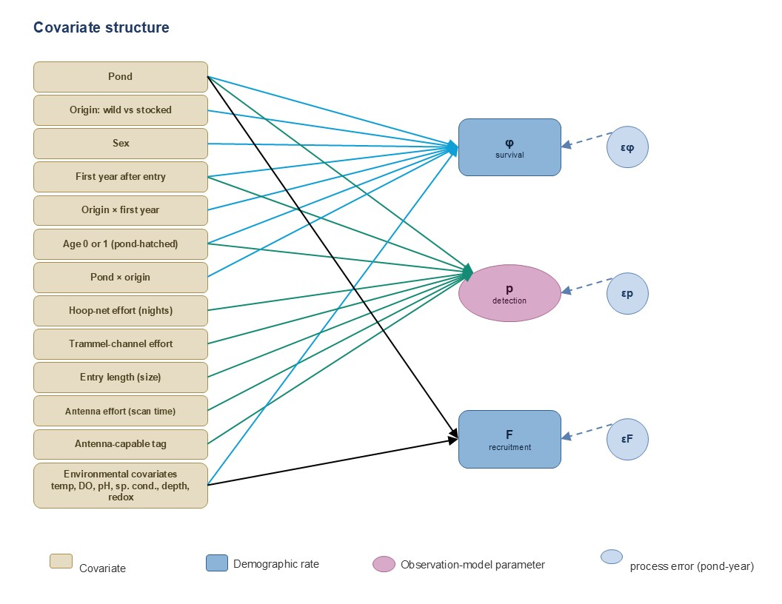
Figure 3. Covariate structure. Tan boxes are covariates; blue lines enter survival φ, green lines enter detection p, and black lines enter recruitment F (pond and environmental covariates). Survey effort reaches recruitment only through detection. Age 0 or 1 enters both survival, as the juvenile steps, and detection, as the catchability of young pond-hatched fish. Light-blue circles are pond-year process errors (εφ, εp, εF).
The dividing line for a covariate is the scale at which it varies, not the number of fish captured. Individual-level covariates (size at release, release method, and sex) vary among fish within a pond, and the environmental covariates (dissolved oxygen, temperature, water level) are measured per pond per year, so both rest on genuine within-pond replication. The individual-level slopes are on firm ground; the environmental slopes are identified from natural year-to-year variation in these variables.
A covariate that instead takes a single value per pond is a different matter. Site identity, or any habitat attribute summarised at the whole-pond scale, has effectively as many observations as there are ponds; pooling individuals to estimate its effect treats non-independent fish as replicates (pseudoreplication) and overstates precision, and with only a handful of ponds the effect is not reliably identifiable by any scheme. Such site-level covariates are reported descriptively unless they can be resolved to the individual or location scale (for example, local bathymetric complexity at each fish's capture site), which returns them to the estimable within-pond set.

7. Key assumptions and caveats
- Open water carries no persistent population. The CJS-only treatment assumes post-release fish do not establish; if meaningful open-water persistence were detected, that assumption would need revisiting.
- Open-water survival is near-zero but strictly positive and estimable. The post-release antenna-contact record shows fish alive for weeks to months before contacts decline: that decline is the CJS signal, so survival is identified on the sub-annual timescale. Annual apparent survival is estimated to be near zero (fish do not persist across years); it is not fixed at zero, since exactly-zero survival would make φ and p non-identifiable.
- OCH ponds are effectively predator-free with demographic continuity. This is what permits a process model and natural-recruitment estimation. The 2020 and 2022 IPCA die-offs (well pump failure; Marsh et al. 2024) removed the entire tagged populations of Pond 5 and Pond 2, and both ponds were restocked; the die-offs are real mortality and are carried in the pond-year survival effects. The dieoff at CHLP in the early 2000s (see Mueller 2006) similarly was due to a one-off massacre after someone ruined a multi-year experiment by releasing largemouth bass into pond, which had been free of at least the large nonnative fishes before then.
- Data are QA/QC'd and individual-level. The model depends on clean, de-duplicated PIT-tag histories linked across institutions.
- Equal catchability at a given length, beyond age 1. The detection correction on the recruit counts applies the netting hazard estimated from tagged fish to pond-hatched fish of the same length before they are tagged; at ages 0 and 1 it adds catchability terms estimated from the timing of first capture, and older untagged fish are assumed as catchable as tagged fish of the same length. The untagged half of the abundance check makes the same assumption for untagged fish in the catch. The tagged half of the check rests instead on antenna detections coming from live fish; tags known to have been shed or recovered are screened out of the encounter histories before the fit.
- Hatch years come from one growth curve. Ages are back-calculated from length through a single curve fitted to wild-hatched fish recaptured in the IPCA ponds, which assumes growth is similar among ponds and years; recaptures of wild-hatched fish are too few in some ponds for pond-specific curves. First-year growth, where ageing is most sensitive, is not directly observed. Assignment error moves recruits between adjacent hatch years, and a slower growth curve is fitted as a sensitivity. Fish without a recorded length are assumed to be a random subset of those measured.
- Spawning age is assumed, not estimated. Spawners are counted from a fixed age at first spawning, which is varied as a sensitivity. Juvenile survival at ages 0 and 1 is estimated but shared across ponds, and survival before a fish can be netted remains inside F.
- The ponds are closed. The population is rebuilt from stocking records and pond-hatched recruits, which assumes no fish enter a pond other than by stocking or hatching there, and that every fish present when a pond's record begins is accounted for by stocking.
- Density dependence is unmeasured, not absent. It is not estimated in the model, so the population growth rates are density-independent.

8. Closing synthesis: from simple to complex
The bonytail analysis is best understood not as a single model but as a deliberate progression of increasing structure (Figure 4). It begins with the simplest defensible model, a survival-only CJS for open-water releases, where fish do not establish, and adds capability only where the data justify it: the off-channel IPM, which estimates survival and detection in the ponds jointly with the pond population and recruitment per spawner (F) and closes the life cycle in the isolated ponds where reproduction occurs (Figure 2); and, at the top, covariate slopes (shared across ponds) fitted on that model's survival and recruitment to identify their drivers and generalize to new sites (Figure 3). The demographic structure is established first, without covariates, so that the covariate slopes are fitted to an already-validated backbone rather than being untangled from survival and recruitment all at once.
Each rung buys more inference but demands more data and more assumptions, so the analysis climbs only as far as each pond's data support. In practice the stages coexist: open-water releases, where fish do not establish, stay at the CJS rung, while the isolated ponds where recruitment closes carry the full IPM, with covariates added where the data support them. The model is scaled to the evidence, not the other way around.
(Figure 4 follows on the next page.)

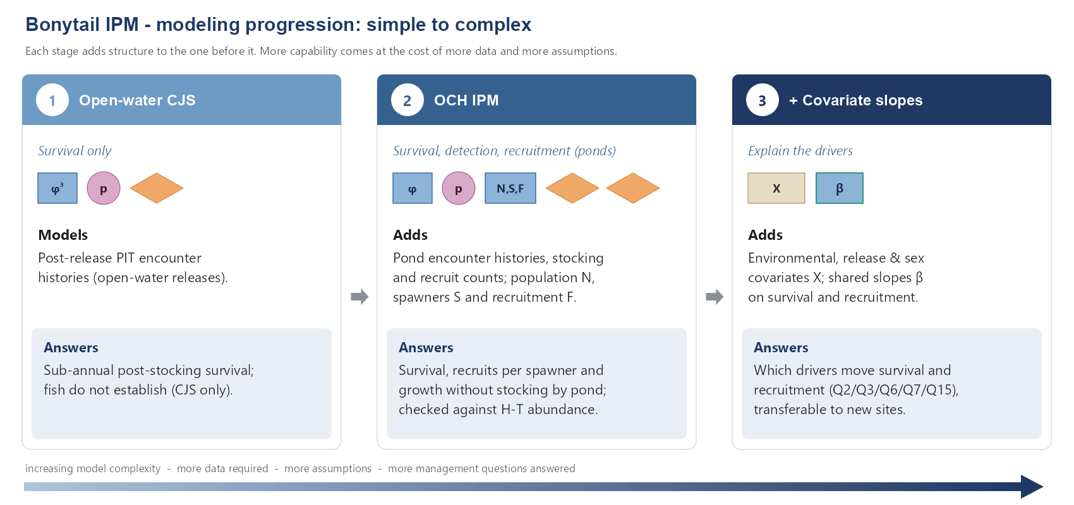
Figure 4. The modeling progression. Each stage adds structure to the one before it; capability rises with the data and assumptions required.

9. Literature Cited
Besbeas, P., S.N. Freeman, B.J.T. Morgan, and E.A. Catchpole. 2002. Integrating mark–recapture–recovery and census data to estimate animal abundance and demographic parameters. Biometrics 58:540–547.
Braun, D.P. 2015. Bonytail (Gila elegans) Basic Conceptual Ecological Model for the Lower Colorado River. Lower Colorado River Multi-Species Conservation Program, Bureau of Reclamation, Boulder City, Nevada.
Braun, D.P. 2019. Bonytail (Gila elegans) Basic Conceptual Ecological Model for the Lower Colorado River, 2018 Updates. Lower Colorado River Multi-Species Conservation Program, Bureau of Reclamation, Boulder City, Nevada.
Buhle, E.R., M.D. Scheuerell, T.D. Cooney, M.J. Ford, R.W. Zabel, and J.T. Thorson. 2018. Using integrated population models to evaluate fishery and environmental impacts on Pacific salmon viability. NOAA Technical Memorandum NMFS-NWFSC-140.
Chapman, D.G. 1951. Some properties of the hypergeometric distribution with applications to zoological sample censuses. University of California Publications in Statistics 1:131–160.
Dzul, M.C., C.B. Yackulic, W.L. Kendall, D.L. Winkelman, M.M. Conner, and M. Yard. 2021. Incorporating antenna detections into abundance estimates of fish. Canadian Journal of Fisheries and Aquatic Sciences.
Fabens, A.J. 1965. Properties and fitting of the von Bertalanffy growth curve. Growth 29:265–289.
Gelman, A., and J. Hill. 2007. Data Analysis Using Regression and Multilevel/Hierarchical Models. Cambridge University Press, New York.
Gimenez, O., B.J.T. Morgan, and S.P. Brooks. 2009. Weak identifiability in models for mark-recapture-recovery data. In D.L. Thomson, E.G. Cooch, and M.J. Conroy, editors. Modeling Demographic Processes in Marked Populations. Springer, New York.
Kelley, J.R., B.R. Kesner, and P.C. Marsh. 2022. Population Status and Distribution of Razorback Suckers and Bonytail Downstream from Palo Verde Diversion Dam, 2016–2021. Submitted to the Lower Colorado River Multi-Species Conservation Program, Bureau of Reclamation, Boulder City, Nevada, by Marsh & Associates, LLC, Tempe, Arizona.
Kéry, M., and M. Schaub. 2012. Bayesian Population Analysis using WinBUGS: A Hierarchical Perspective. Academic Press, Waltham, Massachusetts.
Marsh, P.C., T.E. Dowling, T.F. Turner, M.J. Osborne, and B.R. Kesner. 2024. Maturation of an off-channel habitat concept to conserve native fishes in the Lower Colorado River. Monographs of the Western North American Naturalist 15:Article 1.
Pradel, R. 2005. Multievent: an extension of multistate capture-recapture models to uncertain states. Biometrics 61:442-447.
Schaub, M., and F. Abadi. 2011. Integrated population models: a novel analysis framework for deeper insights into population dynamics. Journal of Ornithology 152:227–237.
Schaub, M., and M. Kéry. 2022. Integrated Population Models: Theory and Ecological Applications with R and JAGS. Academic Press, London.

